Tab 1

# **34. Standard Access Control Lists (ACL)**

## **What are ACLs?**

* ACLs (Access Control Lists) have multiple uses.
* In **Day 34** and **Day 35**, we will focus on ACLs from a **security perspective**.
* ACLs function as a **packet filter**, instructing the **router** to **allow** or **deny** specific traffic.
* ACLs can filter traffic based on:
  + **Source/Destination IP Addresses**
  + **Source/Destination Layer 4 Ports**
  + Other parameters

## **How ACLs Work**

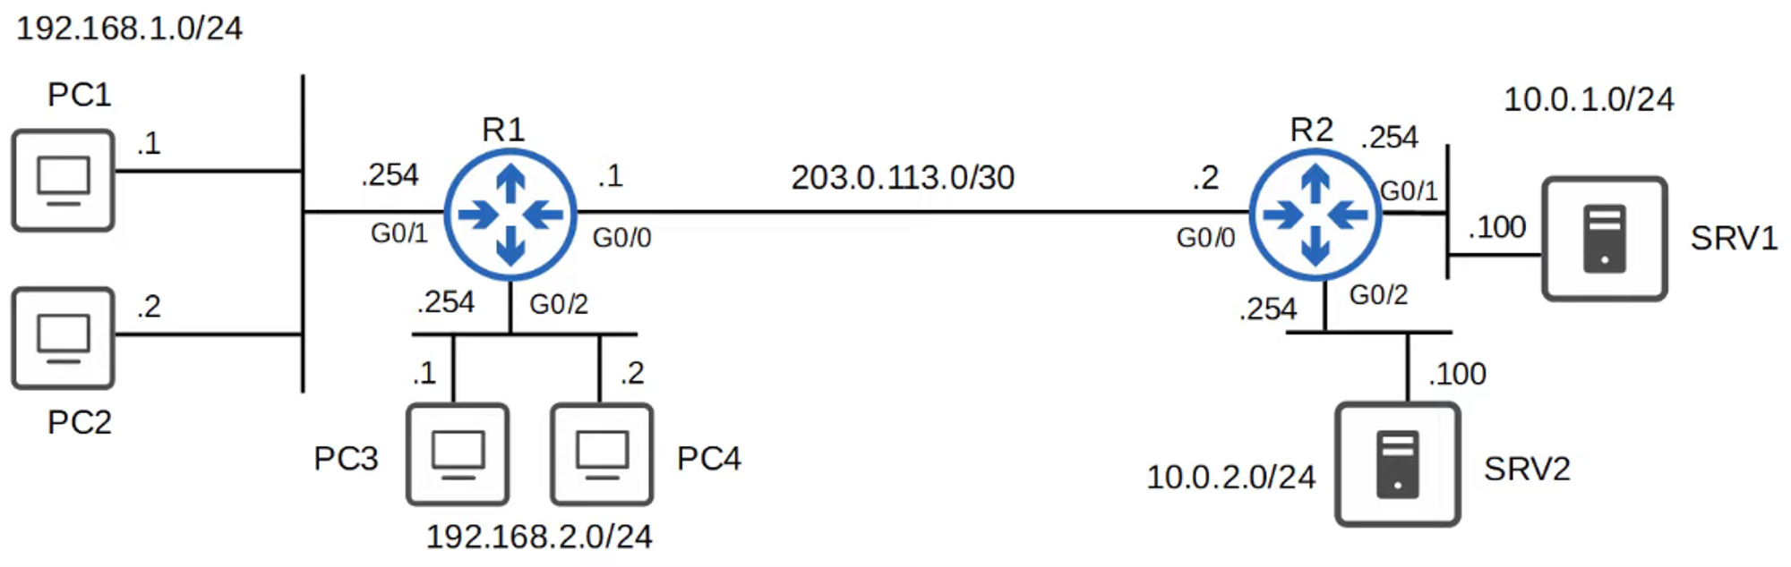

### **Requirements:**

* **Hosts in 192.168.1.0/24** should have **access** to the **10.0.1.0/24** network.
* **Hosts in 192.168.2.0/24** should **not** have **access** to the **10.0.10.0/24** network.

### **ACL Configuration:**

* ACLs are configured **globally** on the router (**Global Config Mode**).
* They are an **ordered sequence** of **Access Control Entries (ACEs)**.

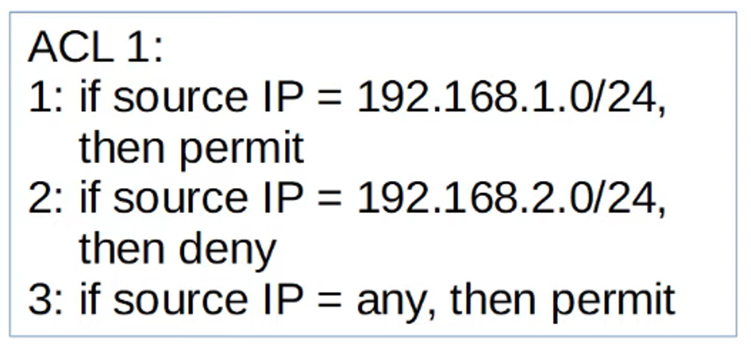

### **Key Points:**

* Configuring an ACL in **Global Config Mode** does **not** automatically activate it.
* The ACL **must be applied** to an interface.
  + ACLs are applied **inbound** or **outbound**.
* ACLs consist of **one or more ACEs**.
* The **router processes ACLs from top to bottom**.
  + If a packet **matches** an ACE, the **router executes the rule and stops processing**.

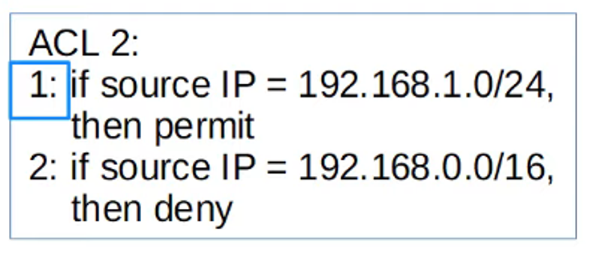

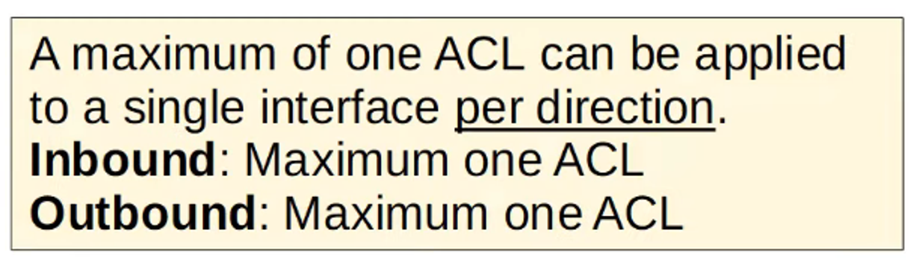

## **Implicit Deny**

* **What happens if a packet doesn’t match any ACL entry?**
* ACLs have an **implicit deny** at the end.
* This **denies all traffic** that doesn’t match a rule in the ACL.

## **ACL Types**

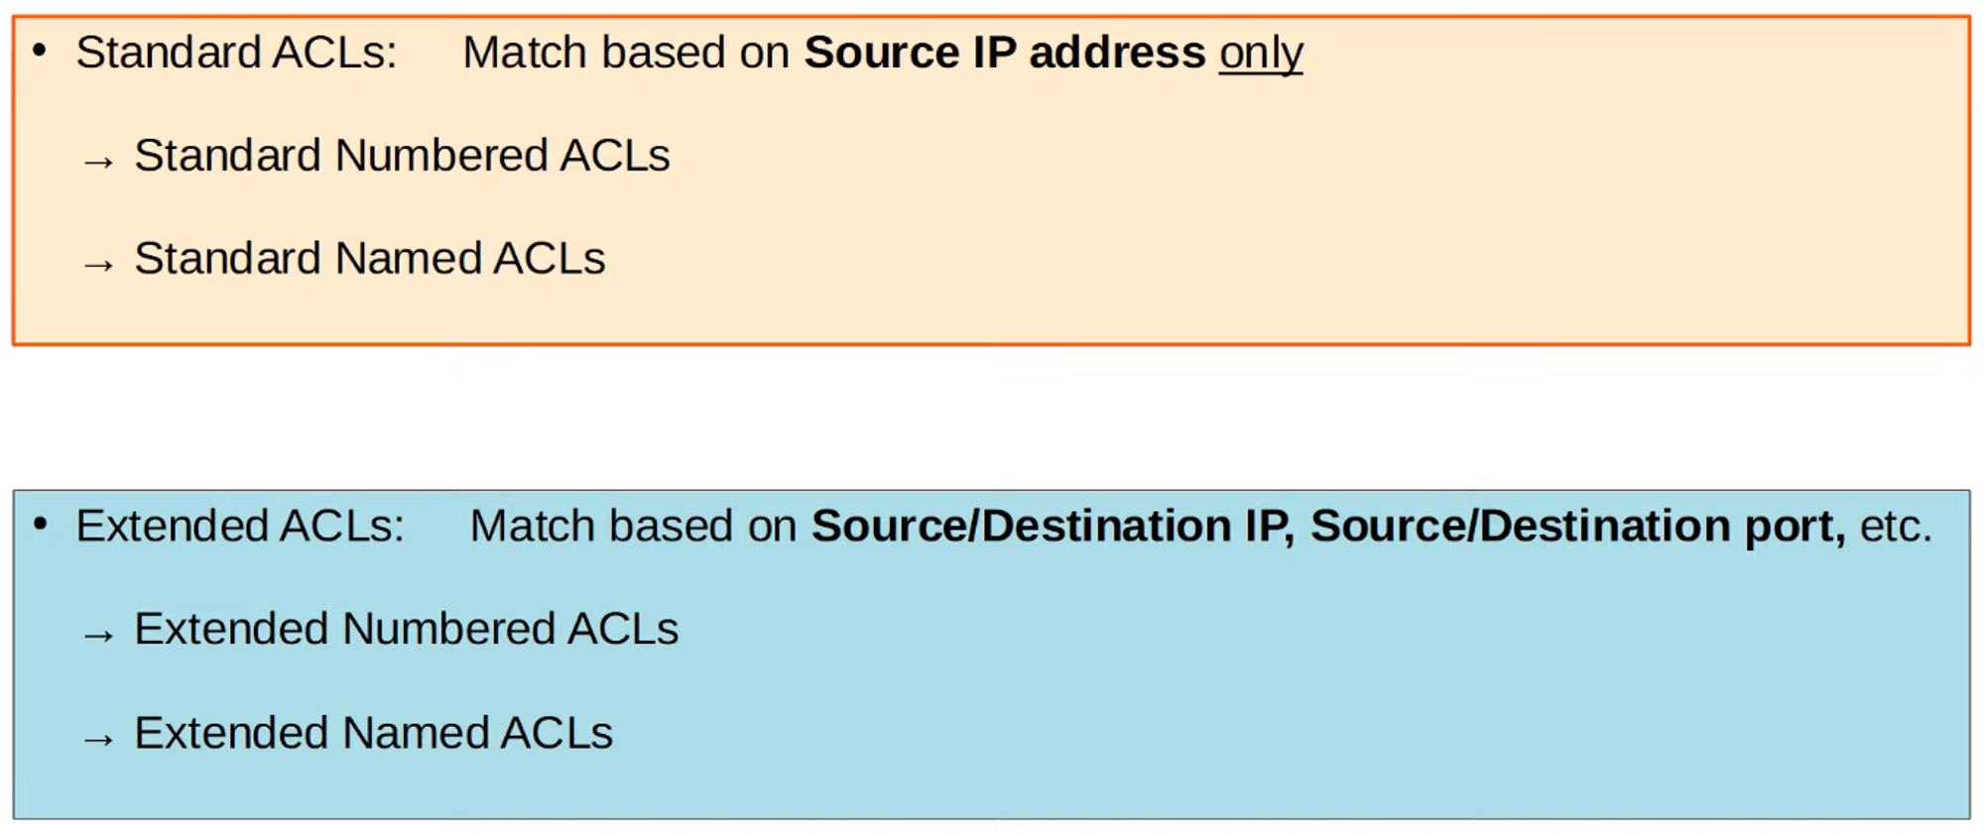

## **Standard Numbered ACLs**

* Matches traffic **only by the source IP address**.
* Identified by **numbers (1-99 and 1300-1999)**.

### **Configuration Command:**

R1(config)# access-list <number> {deny | permit} <ip wildcard-mask>

### **Example:**

R1(config)# access-list 1 deny 1.1.1.1 0.0.0.0 # Blocks a specific host

R1(config)# access-list 1 permit any # Allows all other traffic

### **Adding a Remark (Comment):**

R1(config)# access-list 1 remark ## BLOCK BOB FROM ACCOUNTING ##

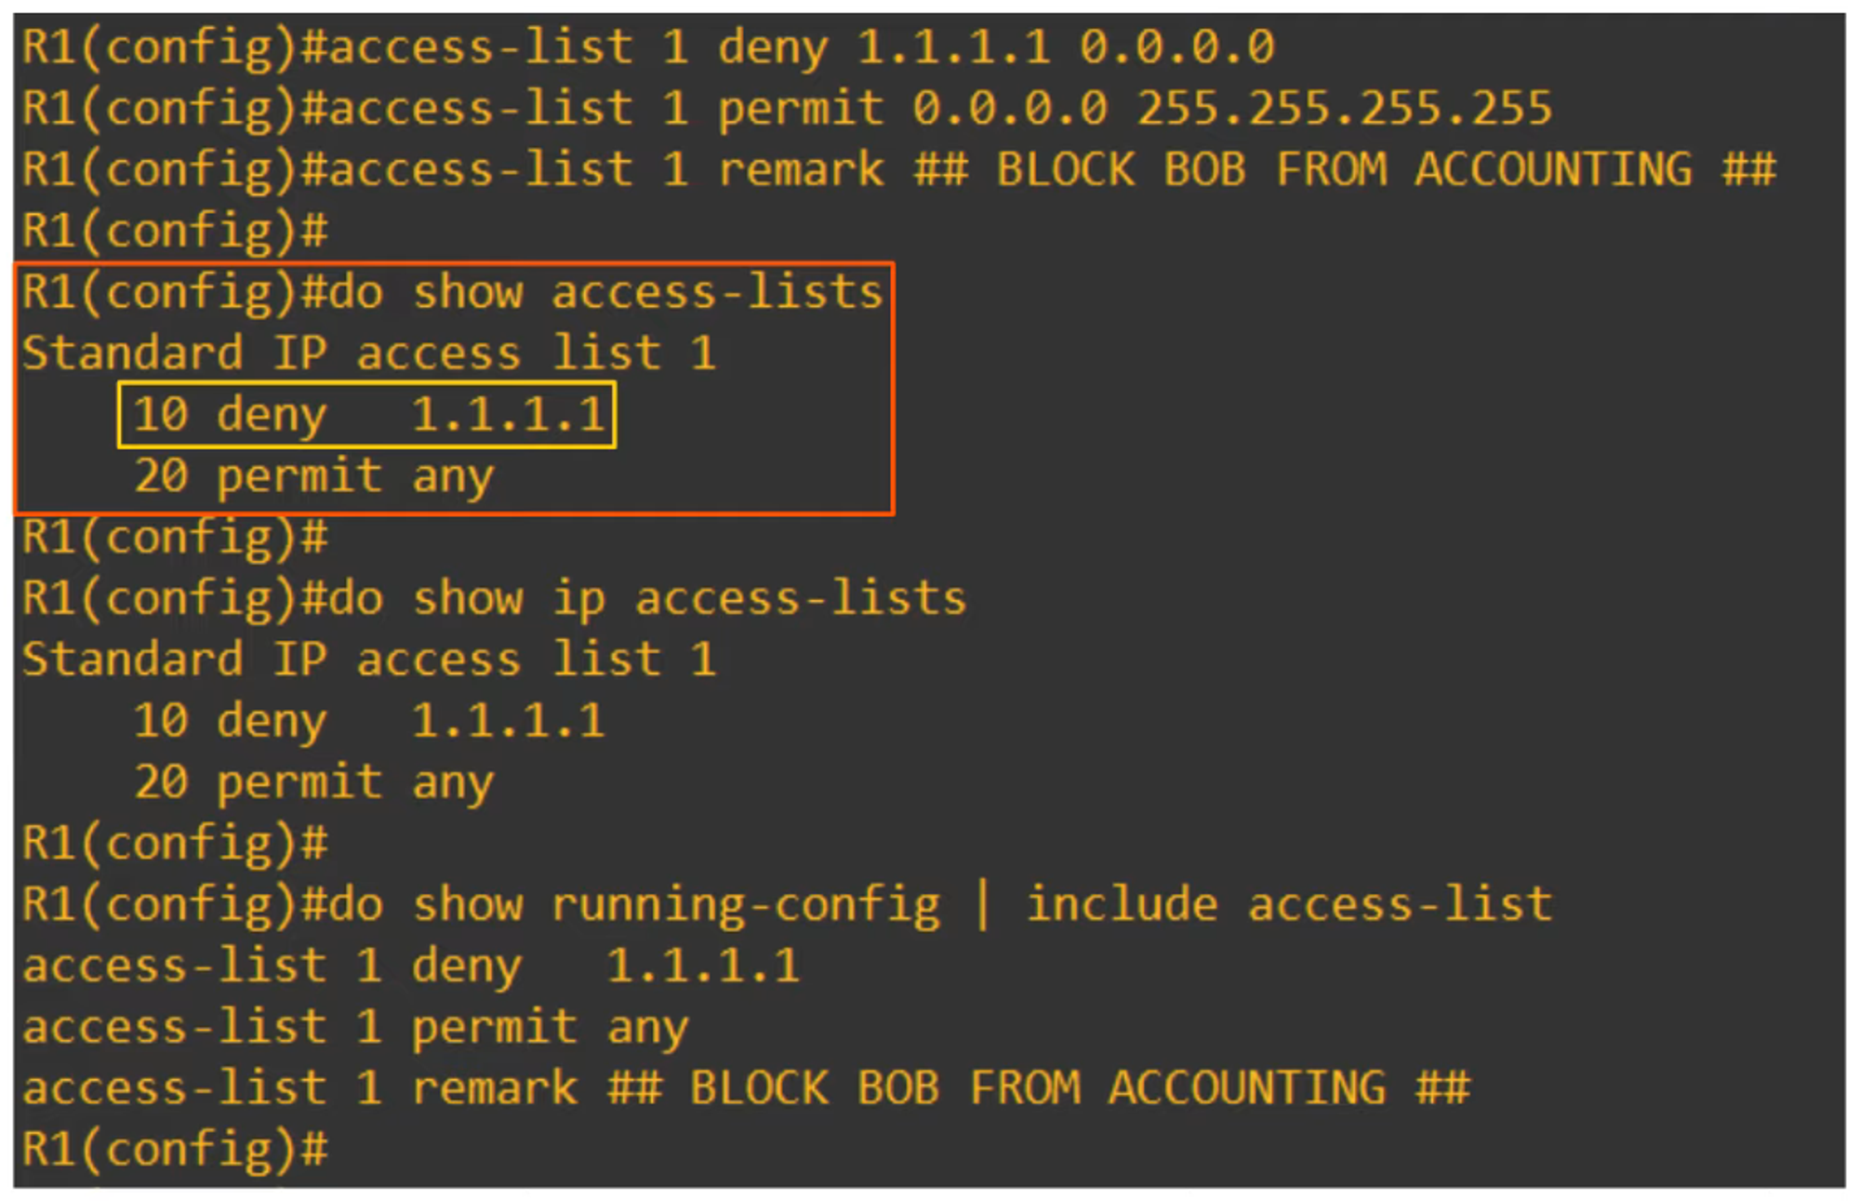

**Order Matters!** Lower-numbered ACL rules are processed first.

## **Applying an ACL to an Interface**

R1(config-if)# ip access-group <number> {in | out}

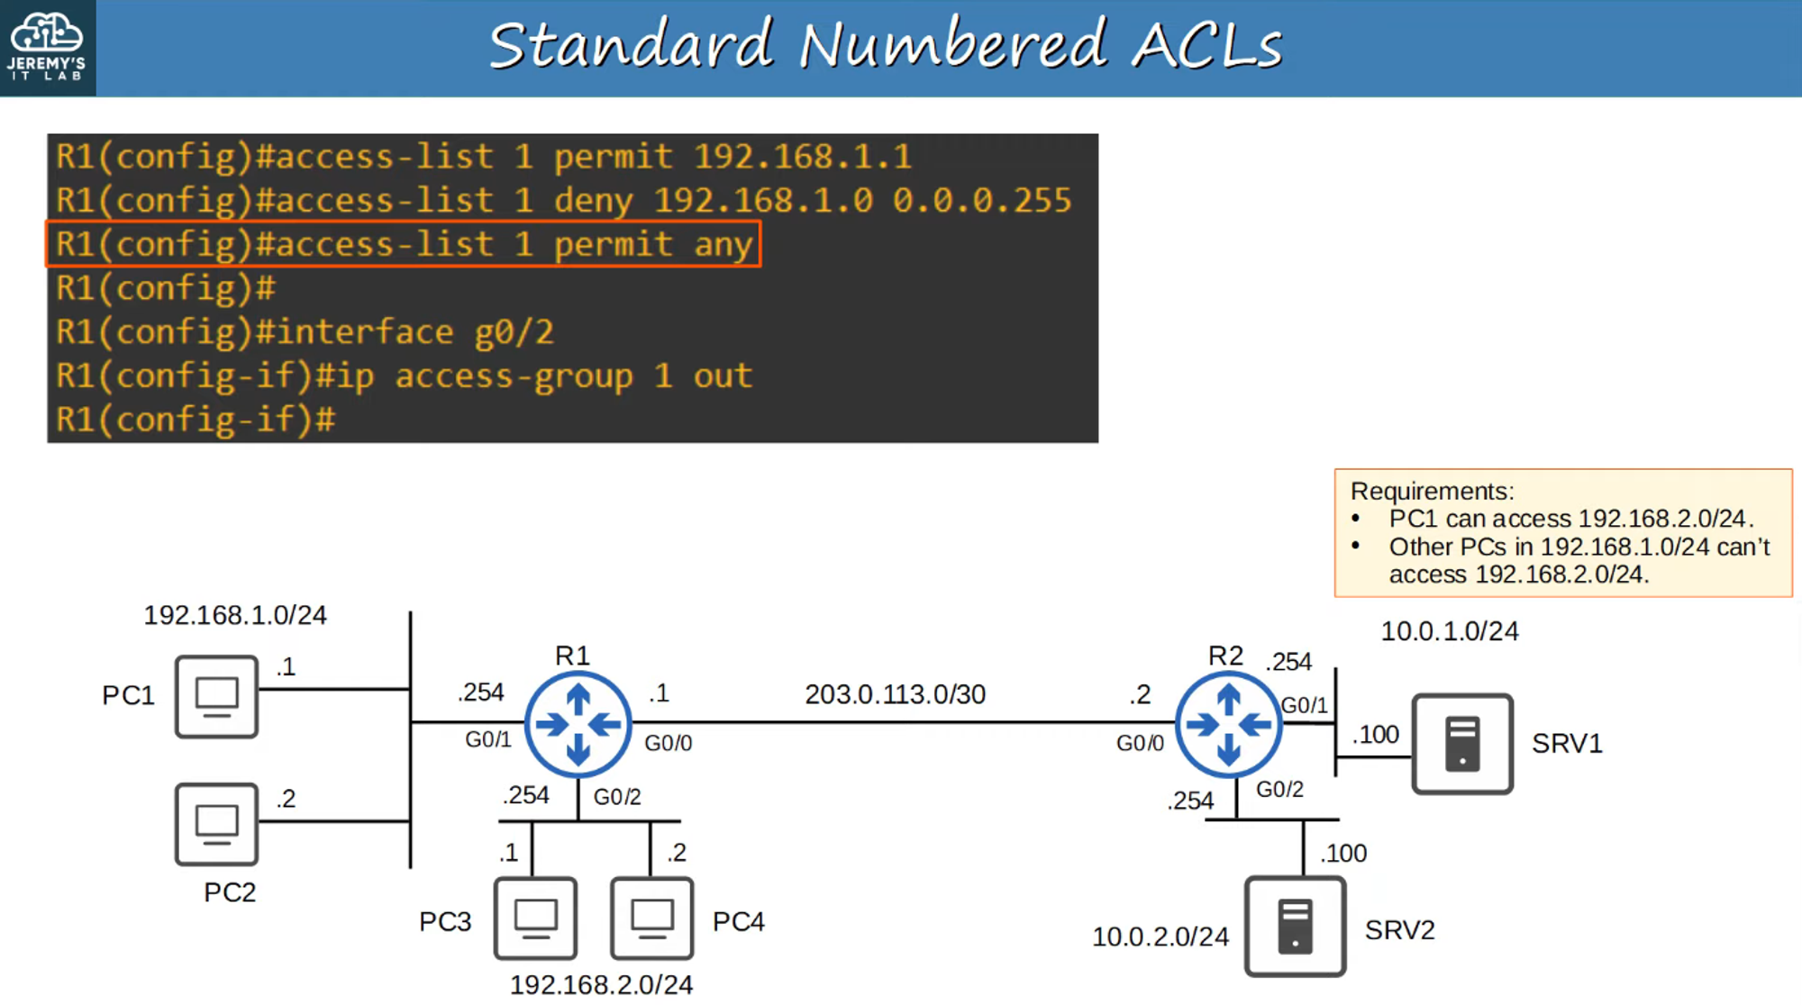

**Why was this rule applied on G0/2 OUT?** **Standard ACLs should be applied as close to the destination as possible!**

## **Standard Named ACLs**

* **Same as Standard Numbered ACLs** but uses **names instead of numbers**.
* Configured using **named ACL mode**.

### **Configuration Commands:**

R1(config)# ip access-list standard <acl-name>

R1(config-std-nacl)# <entry-number> {deny | permit} <ip wildcard-mask>

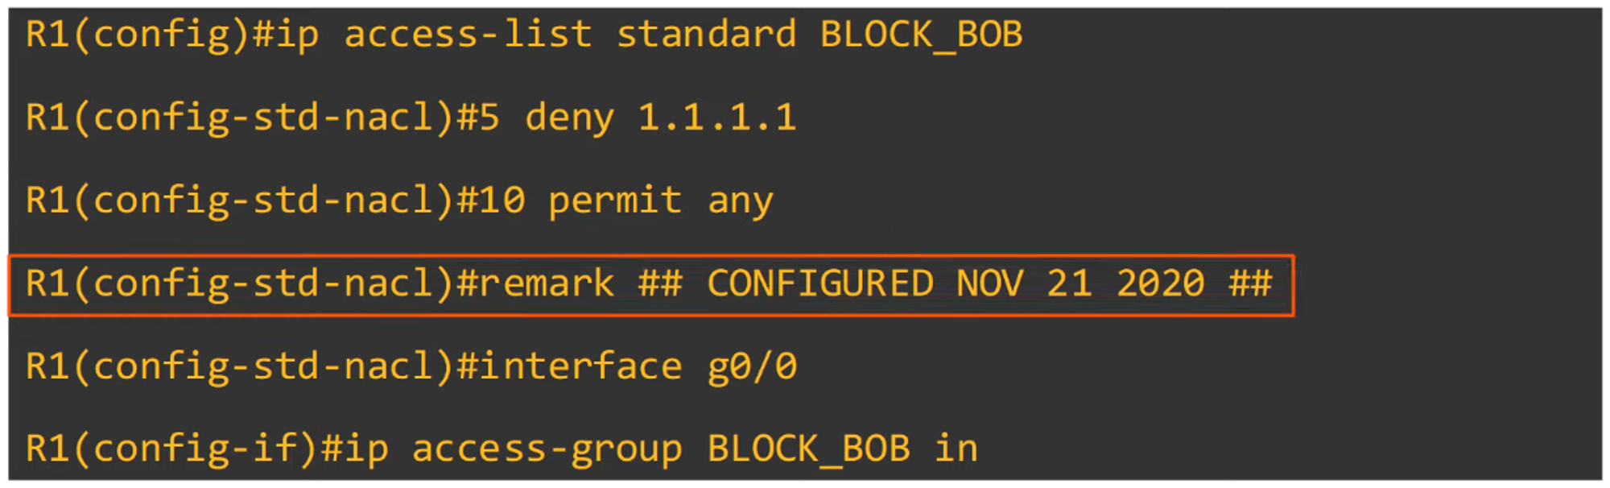

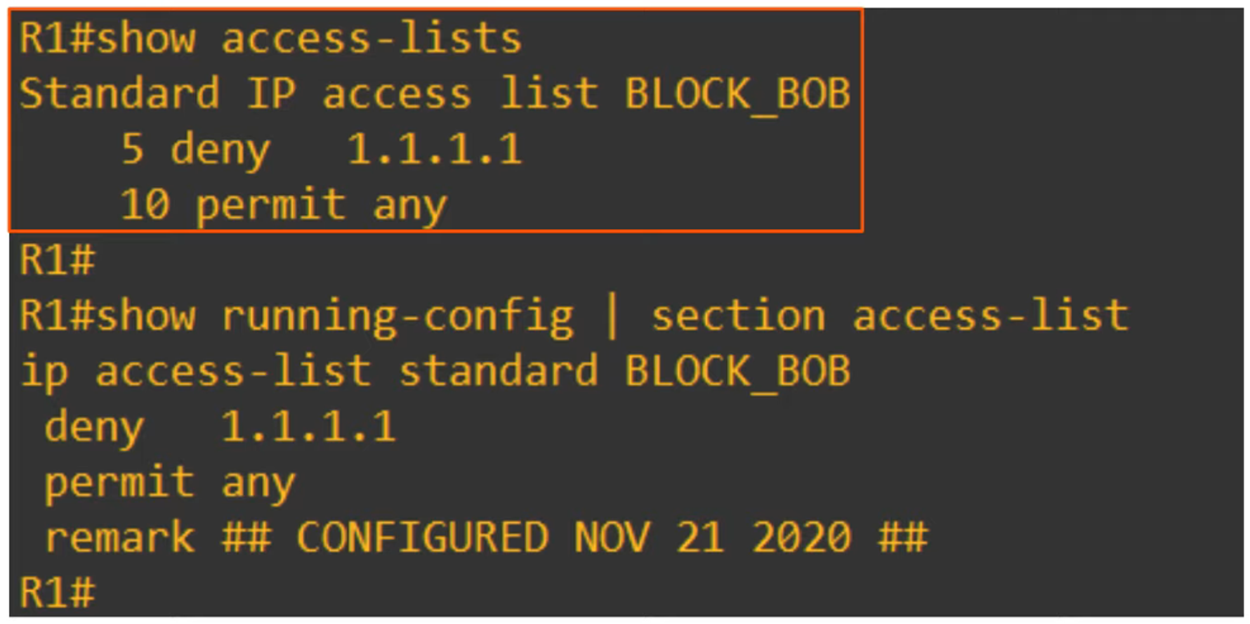

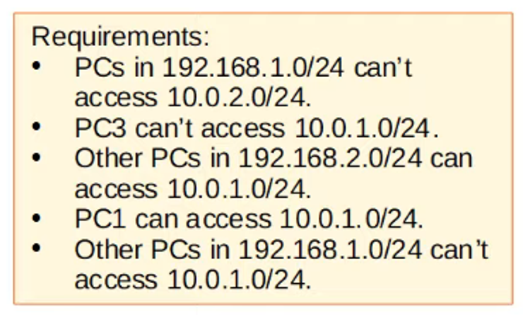

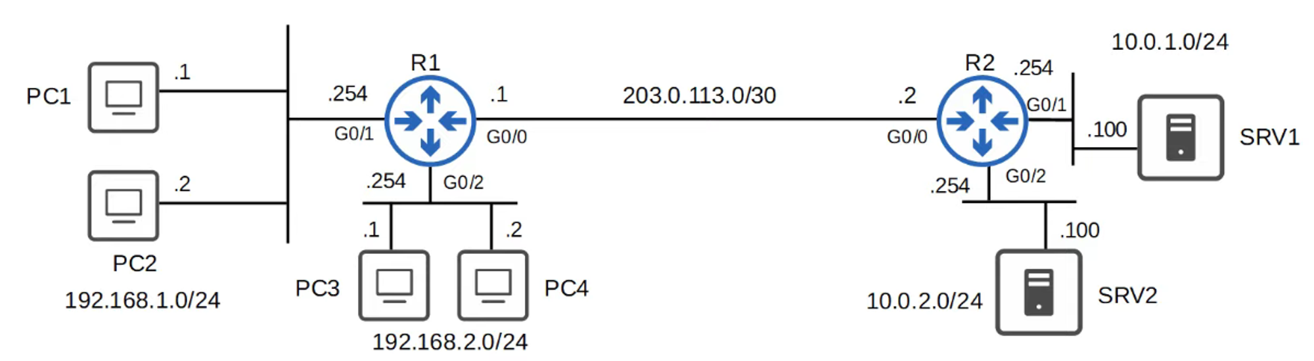

### **Example Configuration:**

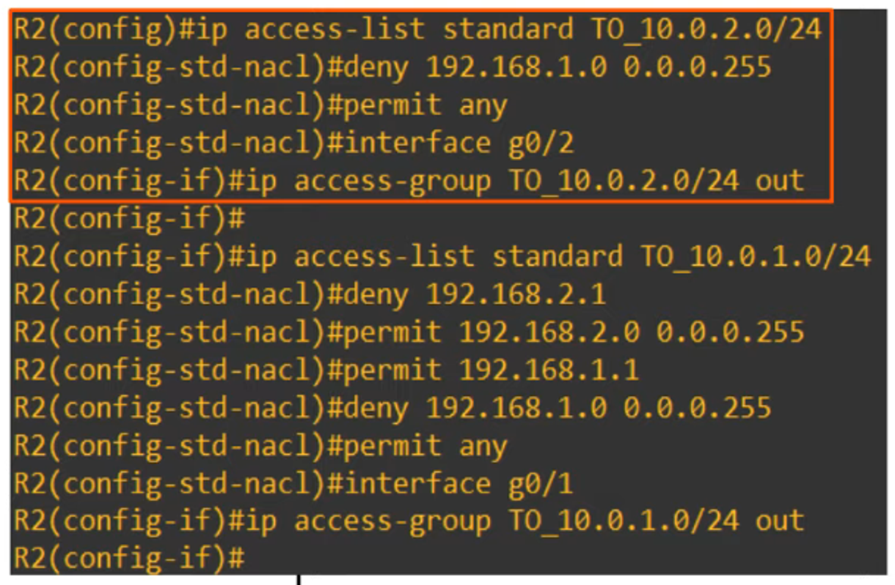

### **Why Reordering Happens:**

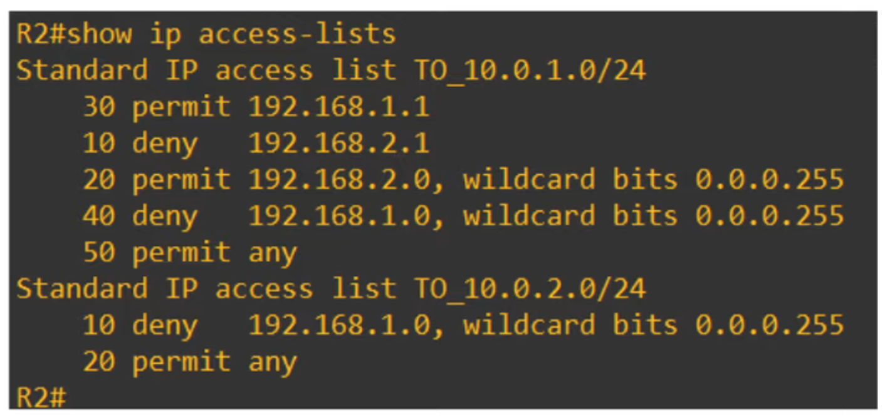

**Note:** **Cisco Packet Tracer does not reorder ACLs**, but real routers do.

This guide provides a structured overview of **Standard ACLs**, their purpose, configuration, and best practices.

Tab 2

# **34. Standard Access Control Lists (ACL)**

## **What are ACLs?**

* ACLs (Access Control Lists) have multiple uses.
* In **Day 34** and **Day 35**, we will focus on ACLs from a **security perspective**.
* ACLs function as a **packet filter**, instructing the **router** to **allow** or **deny** specific traffic.
* ACLs can filter traffic based on:
  + **Source/Destination IP Addresses**
  + **Source/Destination Layer 4 Ports**
  + Other parameters

## **How ACLs Work**



### **Requirements:**

* **Hosts in 192.168.1.0/24** should have **access** to the **10.0.1.0/24** network.
* **Hosts in 192.168.2.0/24** should **not** have **access** to the **10.0.10.0/24** network.

### **ACL Configuration:**

* ACLs are configured **globally** on the router (**Global Config Mode**).
* They are an **ordered sequence** of **Access Control Entries (ACEs)**.



### **Key Points:**

* Configuring an ACL in **Global Config Mode** does **not** automatically activate it.
* The ACL **must be applied** to an interface.
  + ACLs are applied **inbound** or **outbound**.
* ACLs consist of **one or more ACEs**.
* The **router processes ACLs from top to bottom**.
  + If a packet **matches** an ACE, the **router executes the rule and stops processing**.





## **Implicit Deny**

* **What happens if a packet doesn’t match any ACL entry?**
* ACLs have an **implicit deny** at the end.
* This **denies all traffic** that doesn’t match a rule in the ACL.

## **ACL Types**



## **Standard Numbered ACLs**

* Matches traffic **only by the source IP address**.
* Identified by **numbers (1-99 and 1300-1999)**.

### **Configuration Command:**

R1(config)# access-list <number> {deny | permit} <ip wildcard-mask>

### **Example:**

R1(config)# access-list 1 deny 1.1.1.1 0.0.0.0 # Blocks a specific host

R1(config)# access-list 1 permit any # Allows all other traffic

### **Adding a Remark (Comment):**

R1(config)# access-list 1 remark ## BLOCK BOB FROM ACCOUNTING ##



**Order Matters!** Lower-numbered ACL rules are processed first.

## **Applying an ACL to an Interface**

R1(config-if)# ip access-group <number> {in | out}



**Why was this rule applied on G0/2 OUT?** **Standard ACLs should be applied as close to the destination as possible!**

## **Standard Named ACLs**

* **Same as Standard Numbered ACLs** but uses **names instead of numbers**.
* Configured using **named ACL mode**.

### **Configuration Commands:**

R1(config)# ip access-list standard <acl-name>

R1(config-std-nacl)# <entry-number> {deny | permit} <ip wildcard-mask>









### **Example Configuration:**



### **Why Reordering Happens:**



**Note:** **Cisco Packet Tracer does not reorder ACLs**, but real routers do.

This guide provides a structured overview of **Standard ACLs**, their purpose, configuration, and best practices.